Wildfire smoke
Wildfires and smoke are common in Alaska, especially during the warm, dry summer months. Many communities that are safely out of harm’s way from the actual burning can still be impacted by the smoke that can travel many miles. This smoke is made up of gases and small particles that can be harmful if we get exposed. Wildfire smoke can hurt your eyes and lungs and also irritate those with heart and lung disease. Children, older adults, and those with certain preexisting health conditions are especially vulnerable to the negative health effects of wildfire smoke.
Tips to limit expose if a wildfire is creating smoke in your community, include:
- Stay inside. Avoid strenuous outdoor activities like yardwork or running.
- Keep your indoor air as clean as possible by keeping windows and doors shut, using air filters, or using an air conditioner that circulates air inside.
- Get shelter elsewhere if it’s too hot with all your windows closed.
- Don’t pollute your indoor air by using wood stoves, gas stoves, candles, or by smoking inside. Avoid vacuuming since it can also stir up particles.
- Don’t rely on a dust masks or bandanas since they are often not designed to trap small smoke particles. An N-95 respirator can help protect you if worn properly.
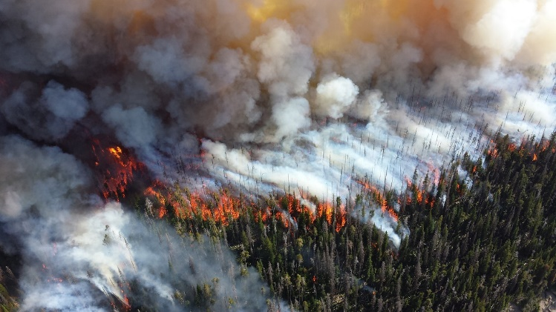
- If leaving to get food or supplies, avoid the smokiest times of day. When driving, go slow, close vents and windows, and recirculate the air already in the car.
- Check local air quality reports and pay attention to health warnings. Check visibility guides if available.
- Talk to your doctor if you have asthma or lung disease about managing your health.
- Prepare for wildfires and have a plan for evacuation.

Since wildfires happen regularly throughout our state, we should try to stay prepared. Being prepared can help limit exposure to the smoke and can help protect your health and the health of your family. For more information, please contact the ANTHC Environmental Health Program at (907) 729-4043 or ceh@anthc.org.

