The History of Handwashing
Our understanding of the benefits of handwashing began in 1846 with Dr. Ignaz Semmelweis. He noticed that that patients of midwives who washed their hands had fewer infections and fevers. He taught his medical student to wash their hands, but when he tried to convince the rest of the medical community, he was put in a mental institution where he died from an infection. In the 1850’s, Florence Nightingale had her nurses practice handwashing, which resulted in fewer infections and more patients surviving their injuries. Finally, in the 1890’s Dr. Robert Koch linked germs to diseases and handwashing then became an accepted practice among medical professionals.
Every year, about 800,000 children die from illnesses that could be prevented by handwashing. To stay healthy and prevent the spread of germs, it’s important to wash our hands when:
- Preparing food
- Before eating food
- Before and after caring for someone at home who is sick
- Before and after treating a cut or wound
- After using the toilet, changing diapers or cleaning a child who has used the toilet.
- After blowing your nose, coughing, or sneezing
- After touching an animal, animal feed, or animal waste
- After touching pet food or treats
- After touching garbage

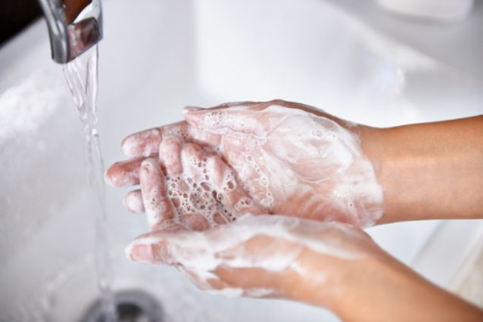
Handwashing steps:
- Wet your hands with clean, running water (warm or cold), turn off the tap, and apply soap.
- Lather your hands by rubbing them together with the soap. Scrub the backs of your hands, between your fingers, and under your nails.
- Scrub your hands for at least 20 seconds. Need a timer? Hum the “Happy Birthday” song twice.
- Rinse your hands well under clean, running water.
- Dry your hands using a clean towel or air dry them.

Washing your hands with soap and water kills the germs and rinses them off your hands. Soap and water is always the best option, but it’s not always available. Hand sanitizers also kill germs, but they do not rinse them off your hands and they are less effective when hands are visibly dirty or greasy. When using hand sanitizer:
- Apply to the palm of one hand (read the label to learn the correct amount).
- Rub your hands together.
- Rub the gel over all the surfaces of your hands and fingers until your hands are dry, this should take around 20 seconds.

Handwashing is one of the simplest things you can do to stay healthy. Our hands touch so many things and washing them frequently with soap and water will help kill all the germs we might have touched before then can make us sick. For more information, please contact the ANTHC Field Environmental Health Program at (907) 729-4043 or ceh@anthc.org.

