Home Ventilation

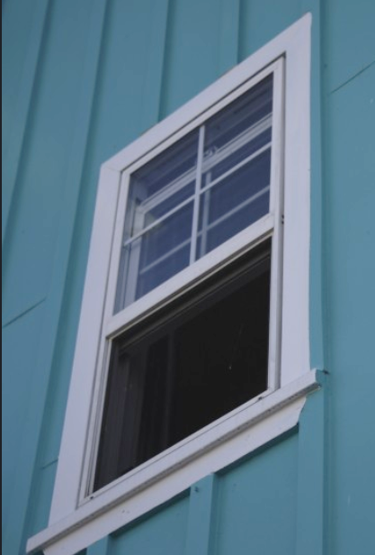
We spend a lot of time in our homes, so we should make sure our indoor air environment is healthy. Ventilation is an important tool for improving indoor air quality and keeping our families healthy. Poor air quality can lead to lung illnesses and cause asthma attacks.

Our indoor air quality can suffer from everyday activities that add pollution or too much moisture to our home’s air. We add pollution when we use wood stoves, cleaning chemicals, or even when burning candles. We add moisture when we cook, shower, wash clothes, and just by breathing. Ventilation replaces this polluted air with fresh air that will help us all breathe easier.

Tips to improve your indoor air:
- Ventilate by opening doors and windows, using bathroom and range hood exhaust fans, or passive air flow vents.
- Ventilate when using cleaning chemicals, paint, nail polish or products that create harmful gases.
- Ventilate when showering, cooking, when you have many guests visiting, or when the windows start to build up condensation.
- Monitor your home’s moisture level with a hygrometer which are available online for about $15. Ventilate when your moisture is over 50%.
- Avoid burning wet wood, treated wood, or garbage. Burn only dry seasoned wood and use good wood burning practices: split, stack, cover, store.
- Don’t open windows near outdoor pollution sources like running vehicles, burning garbage, road dust, or pollen.
- Only smoke outside.

For more information, contact the ANTHC Field Environmental Health Program at (907) 729-4043 or ceh@anthc.org.

