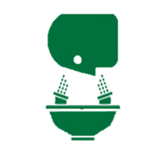**Weekly** **Eyewash Station Safety Inspection Checklist**

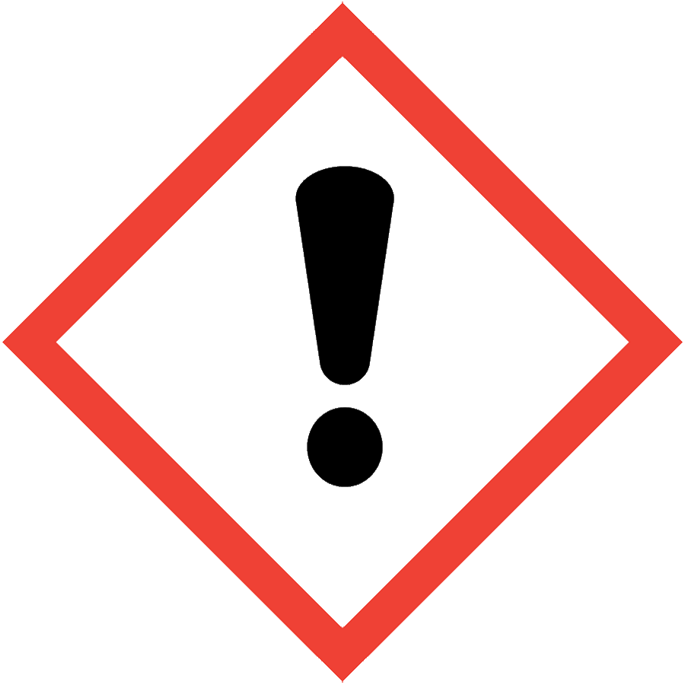

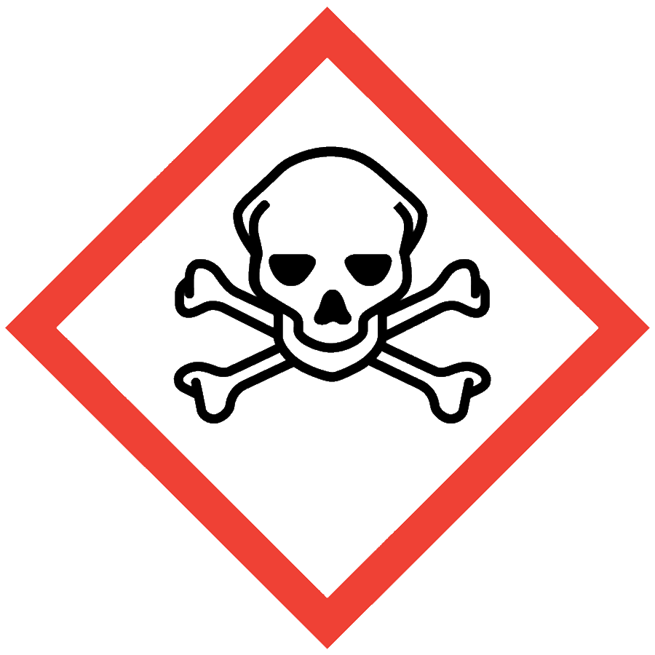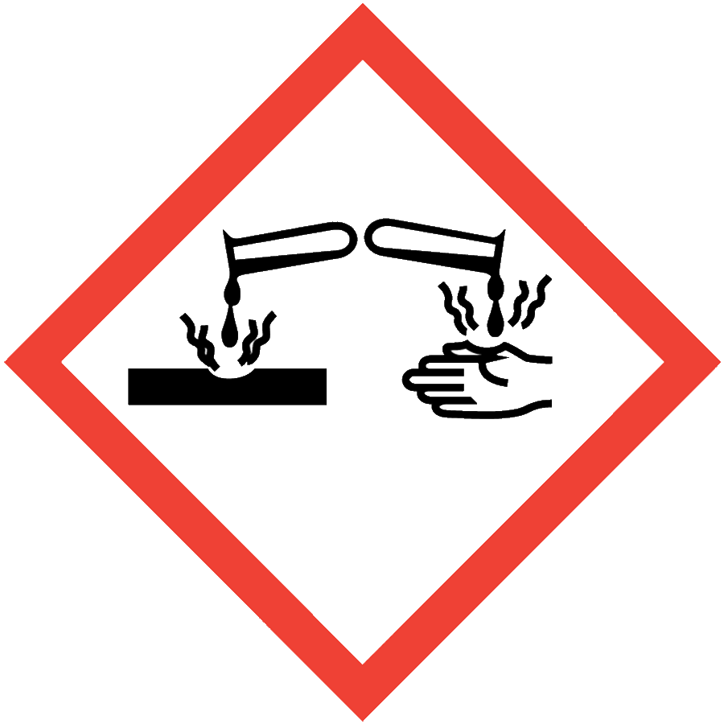

1. Run/Actuate eyewash for at least **2 minutes**

2. Answer all questions below

3. If questions 2-13 result in a ***negative answer***, immediately submit a **work order**.

|  |  |  |  |  |  |
| --- | --- | --- | --- | --- | --- |
|  | **Inspection Date**  (Enter Date Here) | | | | |
| **Department: ­________________________________**  **Eyewash Room #: ______**______________________ |  |  |  |  |  |
|  |
| **Month: ___________________ Year _____________** | **Week**  **1** | **Week**  **2** | **Week**  **3** | **Week**  **4** | **Week**  **5** |
| 1. Staff know the location of equipment and how to operate? |  |  |  |  |  |
| 2. Is the area surrounding the eyewash station free of all obstructions? |  |  |  |  |  |
| 3. Is the eyewash free from sharp projections in the operating area? |  |  |  |  |  |
| 4. Is the eyewash easily activated? *Activates in one second or less?* |  |  |  |  |  |
| 5. Are the nozzles equipped with protective covers? |  |  |  |  |  |
| 6. Are the covers removed by activation of the eyewash? *Remember to recap covers* |  |  |  |  |  |
| 7. Is the water flowing from both eyepieces? |  |  |  |  |  |
| 8. Is the flow of water of equal height? |  |  |  |  |  |
| 9. Is the flow of water clear and warm/tepid? |  |  |  |  |  |
| 10. If not initially clear, does flow become clear after 2 minutes? |  |  |  |  |  |
| 11. Does the spray pattern deliver a steady stream of water? |  |  |  |  |  |
| 12. Does the flow continue until the mechanism is returned to its resting position? |  |  |  |  |  |
| 13. Does the water drain from the bowl/sink? |  |  |  |  |  |
| Comments: Initials of inspector |  |  |  |  |  |
|  |  |  |  |  |  |
|  |  |  |  |  |  |