COVID-19 and the New Normal
Overall, Alaska has done a great job slowing the spread of COVID-19. We’ve been following public health recommendations and the remoteness of Alaska along with our small communities have helped to protect us. However, Alaskan communities are still uniquely vulnerable to outbreaks; especially those with crowded homes and existing issues with access to care and resources. Alaska may be opening back up, be we should all be prepared to live with this new normal for a while.
What is COVID-19? COVID-19 is the name of the disease caused by a new type coronavirus discovered in 2019. Coronaviruses are a very common type of virus. They can cause minor illnesses like the common cold or more serious illnesses like COVID-19. The reason COVID-19 is dangerous is because it’s new to humans, so we don’t know a lot about it and don’t have a vaccine or treatment available. That’s why we will most likely have to continue with precautions like social distancing for a while. These precautions help protect both yours and your neighbors’ health; especially those who are more vulnerable like elders and people with health conditions like heart and lung disease, diabetes, or obesity.
Why are social distancing and handwashing important? COVID-19 is mostly spread from person to person by tiny droplets we breathe out. You can sometimes see larger droplets when you sneeze, but they are also there when you cough, talk, and breathe. Most of the droplets we produce are so small that you cannot see them and can float up to 6 feet through the air. In the case of COVID-19, infectious droplets can be spread by people who don’t feel sick at all. The droplets get into people through our nose, mouth and eyes. That’s why staying 6 feet away from others and wearing a mask, even when feeling healthy, can prevent spreading the virus. Handwashing with soap and water can actually kill the virus and rinse them off your hands. Hand sanitizer can also kill the virus, but it doesn’t remove them, so handwashing is always better if available.
Other ways to protect your community:
- If you cough or sneeze, cover your mouth and nose with your elbow or a tissue.
- When shopping, send only one person, make a list beforehand, and only touch what you buy.
- Getting mail is most likely safe since it takes days or weeks to get to you and the virus only lives on surfaces like cardboard for 24 hours or plastic for 3 days.
- If you are sick or vulnerable, ask a neighbor to do your errands for you.
- Don’t steam bathe with sick people and clean and disinfect the steam in-between uses.
Ways to continue preventing the spread at home:
- Clean and disinfect high touch surfaces like door knobs, counters, and phones.
- If a family member is recovering at home, they should be isolated in one room that others avoid.
- If a family member is sick, the whole family should stay home to prevent spread to neighbors.

COVID-19 updates come almost daily, so it’s important to stay up to date with the right info. Many of us get our news from Facebook or friends and sometimes this can lead to accidentally sharing false information. If you are unsure if something you’ve heard is true, check with a reliable source like the Centers for Disease Control (cdc.gov), AK Department of Health and Social Services (dhss.alaska.gov), or State of Alaska (alaska.gov) before sharing with others.
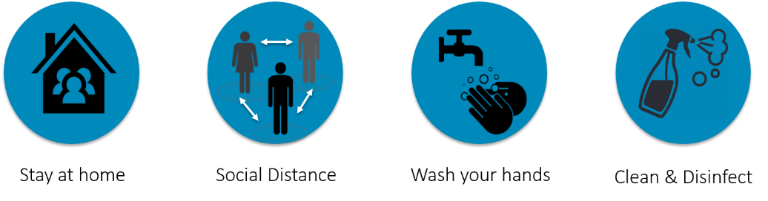
For more resources, please visit: http://www.atcemak.com/covid-19-resource-menu-for-communities/ or contact the ANTHC Environmental Health Program at (907) 729-4043 or ceh@anthc.org.

