Boat Safety
Alaska has thousands of miles of rivers and coastlines that people have depended on for thousands of years. Unfortunately, every year boating accidents and Alaska’s cold waters lead to too many injuries and deaths. Whether operating a large power boat or a small kayak, boat safety should always be considered when going out on the water.
Boat Safety tips:
- Regular maintenance – keep your vessel well maintained and inspect it regularly to prevent any emergencies while on the water.
- Share your float plan – tell someone where you are going and when you expect to return. If you have an emergency, rescuers can be alerted and use this information to locate you faster.
- Drive safely – drive at safe speeds and stay alert for other boats, dangerous obstacles or swimmers. Know the right of way and follow boating rules. Use an engine cut-off device when underway and equip your vessel with a ladder or other means of re-boarding. Be familiar with the waters were you are navigating and consider attending a boat safety class.
- Don’t drink and drive – The pilot should never drink alcohol when out on the water. Alcohol is a leading factor in deadly boating accidents.
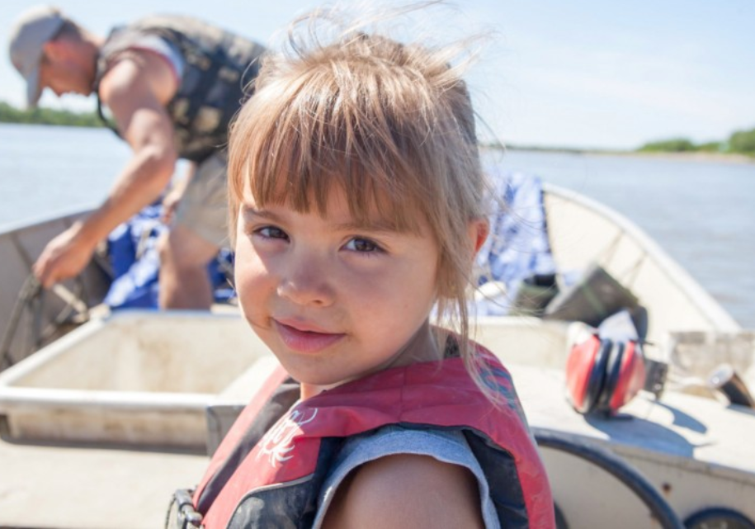
In the event of an emergency, safety gear and supplies can mean the difference between life and death. Some safety gear is required by law for boats of certain sizes. Even if not required by law, consider having the following gear onboard:
- Life jackets
- Throwable floatation devices
- Fire extinguisher
- Visible distress signals (smoke flares and flashlights)
- Sound producing devices (horns or whistles)
- Communication and distress signaling device
- First aid kit
- Paddles, anchor, and rope
- Spare parts, extra fuel and oil, and tools
- Tarps and appropriate clothing for the elements
Life jackets are one of the most important pieces of safety gear. 90% of drowning victims were not wearing a life jacket. In Alaska, boats must have one life jacket for each person on board and children under 13 must wear a life jacket at all times. Youth life jackets can be borrowed and returned for free at “kids don’t float” loaner boards all over Alaska. For both children and adults, it’s important that life jackets fit properly and are well maintained.
Whether using a boat for traveling, fishing, or just for recreation, it’s important to keep boat safety in mind. Boat accidents can happen without warning and being prepared can help protect yourself and your passengers in an emergency. For more information, please contact the ANTHC Field Environmental Health Program at (907) 729-4043 or ceh@anthc.org.

