ALASKA AREA
COMMISSIONED OFFICER AWARDS BOOKLET

2015

References
- CC 27.1.1 Awards Program, 8/07
- CCPM Pamphlet 67, 6/98
- http://bphc.hrsa.gov/nhdp/RIBBONS_MAIN_PAGE.htm

Introduction 4
Types of Awards 4

Distinguished Service Medal (DSM) 4

Meritorious Service Medal (MSM) 4

Outstanding Service Medal (OSM) 4

Commendation Medal (CM) 4

Achievement Medal (AM) 4

PHS Citation (CIT) 4

Outstanding Unit Citation (OUC) 4

Unit Commendation (UC) 5
Tips For a Successful Nomination 5
Common Reasons a Nomination May Be Rejected 5
Speical issues 5
Alaska Area Awards Board 7

Meeting Schedule 7

Alaska Area Board Members 7
CO Award Nomination Checklist 8
INDIVIDUAL HONOR AWARD Cover Sheet part I 10
INDIVIDUAL HONOR AWARD Cover Sheet part II 11
Narrative Example 12

Cited For 12

Example 12

Background 12

Example 12

Accomplishments 12

Minimum Requirements 12

Example 13

Impact/Outcome 13

Minimum Requirements 13

Example 13

Conclusion 14

Example 14
Alternative Narrative Layout 14
Unit honor award Cover Sheet part i 15
Unit honor award Cover Sheet part i 16

Alaska Area Commissioned Officer Awards

The Commissioned Officers Awards Program is designed to give formal recognition to officers who have performed particularly well in carrying out the mission of the U.S. Public Health Service. The awards system is intended to be objective, not competitive. Award nominations must be in accordance with the established Commissioned Corps Personnel Manual Policy.

The award cycle year starts on July 1 and ends June 30 of each year.

Types of Awards

Distinguished Service Medal (DSM)
Recognizes outstanding contributions to the mission of the PHS, an initiative that has major impact on the health of the Nation, management of a major health program, or involvement in a heroic act resulting in an exceptional saving of life, health, or property. Final approval is by the Surgeon General.

Meritorious Service Medal (MSM)
Recognizes a single, particularly important achievement, a career notable for accomplishments in a technical or professional field, or leadership of an unusually high quality and initiative. Final approval is by the Surgeon General.

Outstanding Service Medal (OSM)
Recognizes outstanding continuous leadership in carrying out the mission of the PHS, a single accomplishment that has had a major effect on the health of the Nation, or a heroic act resulting in the preservation of health or property. Final approval is by the Surgeon General.

Commendation Medal (CM)
Recognizes sustained high quality work performance in scientific, administrative, or other professional fields, application of unique skill or creative imagination to the approach or solution of problems, or noteworthy technical and professional contributions that are significant to a limited area at a level of proficiency and dedication distinctly greater than that expected of the average commissioned officer. Final approval is by the IHS CCAB.

Achievement Medal (AM)
Recognizes a noteworthy contribution(s) toward the attainment of Program objectives, or sustained above-average performance of duty over a relatively brief period such as a short tour of duty (120 days or less). Final approval is by the AK Area CCAB.

PHS Citation (CIT)
Recognizes noteworthy contribution(s) toward the attainment of Program objectives, sustained above-average performance of duty, and high quality performance of duty over a relatively short period of time. Final approval is by the AK Area CCAB.

Outstanding Unit Citation (OUC)
The OUC is awarded to officers of a unit that exhibits superior service toward achieving the goals and objectives of the PHS. To merit this award, the unit must provide exceptional service, often of national international significance.

Unit Commendation (UC)
The UC acknowledges an outstanding accomplishment by a designation organizational unit within PHS that has demonstrated a significant level of performance well above that normally expected, but at a somewhat lesser level than is required for the OUC.

Tips for a Successful Nomination

- Nominee should contribute to or write the narrative since they know the work and affect the best.
- Be sure the nomination includes the appropriate “key words” for the specific award (e.g. OSM nominations should include “for outstanding continuous leadership”).
- There are six individual levels of awards. The words in the narrative should be reflective of the words for the level of the award, e.g. if the proposed award is an OSM for continuous leadership, then the text should focus on examples of leadership.
- Write the nomination first then decide the appropriate level of award.
- Ensure the specific role of the officer in the activity is clearly explained. Address any obstacles or difficulties the officer had to overcome and how the officer used his/her unique skills to address those barriers successfully.
- Emphasize the public health impact of the activity.
- Include specific information, especially quantitative information, whenever possible (avoid terms like some, many, etc.).
- Use these types of terms: “established, founded, organized, chaired, provided leadership, led, developed a unique, implemented a major, essential, exemplary service, role model, motivated other to pursue excellence, negotiated with, and used expertise following collaborative review of…”

Common Reasons a Nomination May Be Rejected

- The specific role of the officer is not clearly explained. It is not sufficient to say an officer led a project and then provide no further detail on what actually was involved.
- The impact of the activity is not well described (most common mistake). Impact statements describe the strong effect or result of the officers’ accomplishment had on the public health.
- The nomination is too technical.
- Quantitative information is omitted.
- The accomplishments and activities are not appropriate for the level of award.
- The awards appear to overlap with a previous award with no explanation. Address the distinction between this award if there is any chance it will be questioned as overlapping.
- Failure to adhere to formatting requirements. Wrong font size, font type, typos, or incorrect use of officer’s title.

Special Issues

Overlapping awards
An officer may not receive two awards for the same accomplishments.

Individual vs. unit awards

If a nomination is for a single accomplishment involving many persons, a unit award should be made for all involved including the leader. An officer is not eligible for an individual and a unit award at the same time for the same work unless it is shown that the individual made additional contributions and impact well beyond what is in the unit nomination.

Timing of Nomination and Responses
Honor award nominations must be submitted within 13 month after the activities occurred. The 13-month period is calculated from the end of the “Period Covered” date. The award nomination must be submitted to the Alaska Area Awards Board within this 13 month period. Awards submitted after the 13 month period will not be considered.

During the award review process, if an award is returned to the nominator/nominee for correction, clarification or re-write, the award must be resubmitted to the Alaska Area Awards Board within 60 days of the request. If the needed action is not received within the 60 day period, the award will be placed on “inactive” status; the Alaska Area Awards Board will take no further action.

LINKS TO FORMS AND POLICY

http://www.anthc.org/cs/coawards/

Alaska Area Awards Board

2015 Meeting Schedule

JANUARY |  |  |  |  |  |  |  | FEBRUARY |  |  |  |  |  |  |  | MARCH
S | M | T | W | T | F | S |  | S | M | T | W | T | F | S |  | S | M | T | W | T | F | S
 |  |  |  | 1 | 2 | 3 |  | 1 | 2 | 3 | 4 | 5 | 6 | 7 |  | 1 | 2 | 3 | 4 | 5 | 6 | 7
4 | 5 | 6 | 7 | 8 | 9 | 10 |  | 8 | 9 | 10 | 11 | 12 | 13 | 14 |  | 8 | 9 | 10 | 11 | 12 | 13 | 14
11 | 12 | 13 | 14 | 15 | 16 | 17 |  | 15 | 16 | 17 | 18 | 19 | 20 | 21 |  | 15 | 16 | 17 | 18 | 19 | 20 | 21
18 | 19 | 20 | 21 | 22 | 23 | 24 |  | 22 | 23 | 24 | 25 | 26 | 27 | 28 |  | 22 | 23 | 24 | 25 | 26 | 27 | 28
25 | 26 | 27 | 28 | 29 | 30 | 31 |  |  |  |  |  |  |  |  |  | 29 | 30 | 31
APRIL |  |  |  |  |  |  |  | MAY |  |  |  |  |  |  |  | JUNE
S | M | T | W | T | F | S |  | S | M | T | W | T | F | S |  | S | M | T | W | T | F | S
 |  |  | 1 | 2 | 3 | 4 |  |  |  |  |  |  | 1 | 2 |  |  | 1 | 2 | 3 | 4 | 5 | 6
5 | 6 | 7 | 8 | 9 | 10 | 11 |  | 3 | 4 | 5 | 6 | 7 | 8 | 9 |  | 7 | 8 | 9 | 10 | 11 | 12 | 13
12 | 13 | 14 | 15 | 16 | 17 | 18 |  | 10 | 11 | 12 | 13 | 14 | 15 | 16 |  | 14 | 15 | 16 | 17 | 18 | 19 | 20
19 | 20 | 21 | 22 | 23 | 24 | 25 |  | 17 | 18 | 19 | 20 | 21 | 22 | 23 |  | 21 | 22 | 23 | 24 | 25 | 26 | 27
26 | 27 | 28 | 29 | 30 |  |  |  | 24/31 | 25 | 26 | 27 | 28 | 29 | 30 |  | 28 | 29 | 30
JULY |  |  |  |  |  |  |  | AUGUST |  |  |  |  |  |  |  | SEPTEMBER
S | M | T | W | T | F | S |  | S | M | T | W | T | F | S |  | S | M | T | W | T | F | S
 |  |  | 1 | 2 | 3 | 4 |  |  |  |  |  |  |  | 1 |  |  |  | 1 | 2 | 3 | 4 | 5
5 | 6 | 7 | 8 | 9 | 10 | 11 |  | 2 | 3 | 4 | 5 | 6 | 7 | 8 |  | 6 | 7 | 8 | 9 | 10 | 11 | 12
12 | 13 | 14 | 15 | 16 | 17 | 18 |  | 9 | 10 | 11 | 12 | 13 | 14 | 15 |  | 13 | 14 | 15 | 16 | 17 | 18 | 19
19 | 20 | 21 | 22 | 23 | 24 | 25 |  | 16 | 17 | 18 | 19 | 20 | 21 | 22 |  | 20 | 21 | 22 | 23 | 24 | 25 | 26
26 | 27 | 28 | 29 | 30 | 31 |  |  | 23/30 | 24/31 | 25 | 26 | 27 | 28 | 29 |  | 27 | 28 | 29 | 30
OCTOBER |  |  |  |  |  |  |  | NOVEMBER |  |  |  |  |  |  |  | DECEMBER
S | M | T | W | T | F | S |  | S | M | T | W | T | F | S |  | S | M | T | W | T | F | S
 |  |  |  | 1 | 2 | 3 |  | 1 | 2 | 3 | 4 | 5 | 6 | 7 |  |  |  | 1 | 2 | 3 | 4 | 5
4 | 5 | 6 | 7 | 8 | 9 | 10 |  | 8 | 9 | 10 | 11 | 12 | 13 | 14 |  | 6 | 7 | 8 | 9 | 10 | 11 | 12
11 | 12 | 13 | 14 | 15 | 16 | 17 |  | 15 | 16 | 17 | 18 | 19 | 20 | 21 |  | 13 | 14 | 15 | 16 | 17 | 18 | 19
18 | 19 | 20 | 21 | 22 | 23 | 24 |  | 22 | 23 | 24 | 25 | 26 | 27 | 28 |  | 20 | 21 | 22 | 23 | 24 | 25 | 26
25 | 26 | 27 | 28 | 29 | 30 | 31 |  | 29 | 30 |  |  |  |  |  |  | 27 | 28 | 29 | 30 | 31
 | Deadline for submission of awards for monthly meetings. |  |  |  |  |  |  |  |  |  | Regular Alaska Area Awards Board Meeting.

- If a nomination is received on or before the 10th day of the month, then the AK Area Commissioned Corps Awards Board will review the nomination at the next meeting.
- If a nomination is received after the 10th day of the month, then the AK Area Commissioned Corps Awards Board will review the nomination the following month.
- Awards not adhering to these guidelines and/or checklist will not be reviewed by the Alaska Area Awards Board. Awards not adhering to these guidelines and/or checklist will be returned to the nominator and/or nominee for revision before review by the Alaska Area Awards Board.
- Incomplete nominations will not be reviewed by the Alaska Area Awards Board.
- Incomplete nominations will be returned to the nominator and will not begin the review process until the requirements are met.

Alaska Area CC Awards Board Members

Name | Category | Email Address
CAPT Jeff Smith | Environmental Health | jjsmith@anthc.org
CAPT Susan Thompson | Nurse | sethompson@SouthcentralFoundation.com
LCDR Nicolette Bennett | Dental Hygienist | nkbennett@scf.cc
LCDR Kevin Bingley | Environmental Engineer | Kevin.bingley@ihs.gov
LCDR Christina Eldridge | Pharmacist | cjeldridge@anthc.org
CDR Dale King | Physical Therapist | dwking@anthc.org
CDR Kenneth Norris | Medical Director | KNorris@SouthcentralFoundation.com
CAPT Michale Ratzlaff | Medical | mdratzlaff@scf.cc
Shoffstall-Cone, Sarah | Clinical Site Director | sshoffstallcone@anthc.org
Nominations and Questions: Contact Blanche Demientieff at: btdemientieff@anthc.org

CO Award Nomination Checklist

NOMINEE Name
Proposed Award |  |  |  | May we contact the NOMINEE for questions? |  | Yes No
Nominator (Person completing this form)
Nominator’s Title
Phone |  |  | Email

Nomination Requirements (Initial each one to confirm that you have completed the requirements and that you understand what is required)

- Nomination Award submitted within 13 months of the “end date” listed in the “Period Covered” of the Part I coversheet.
- Electronic Copies of the CO Award Nomination Checklist, Cover Sheet, and Narrative e-mailed to _AKA-CCAB@anthc.org. Documents are in the Microsoft Word/PDF format only.
~Signatures are not required until nomination is approved by the AK CO Awards Board~

NARRATIVE
- 2 pages maximum
- All margins are 1 inch
- Font size is at least 12 points
- Font type is either Courier, Arial or Times New Roman
- Use rank throughout abbreviated as LTJG, LT, LCDR, or CAPT. Do not use Dr., Ms., Mr., etc.
- Avoid highly technical language or undefined abbreviations (let the facts speak for themselves).
- _____Define abbreviations on 1st use then use abbreviation consistently through the remainder of the document. Do not use an abbreviation only once.
- Avoid the use of future tenses (i.e. “will) for impacts.
- Avoid passive language (i.e. instead of “has been involved” use “was involved”).

COVER SHEET (PHS-6342) PART I

- Officer’s full name (First, Last MI)
- Original entry on duty date (mm/dd/yyyy)
- Rank (i.e. O-1 through O-10: please note the abbreviation is a letter as in Officer, not a zero)
- PHS professional category must be one of the following: Medical, Dental, Nurse, Engineer, Scientist, Environmental Health, Veterinary, Pharmacy, Dietetics, Therapy, Health Service
- 7-digit Employee ID Number
- Current organization format for Alaska is USPHS/IHS/AANHS/My Organization/My City, AK. Change only “My Organization/My City”.
- Proposed award name (PHS Citation, Achievement Medal, Commendation Medal, etc)
- Organization position title
- Period covered as numerical month and year only (mm/yyyy to mm/yyyy) Do not enter “Present” as an ending date.
- Cited for (description of the specific reason for which the officer is being nominated. The description must match exactly the citation in the opening and closing paragraphs of the narrative; 25-word limit or 180 characters) Do not repeat the dates in the citation on the cover sheet.
- Nominator name and title (Awards must be submitted within 13 months of the “end date”. Do not sign or date when submitting award.

ENDORSEMENTS
1._____ For CM or above enter the supervisor in the “Supervisory/Line of Authority”. If this name is already in the Nominator “Name and Title” box, then enter the next line of authority.

COMMENT
1._____ If the officer is from another agency, obtain supervisor concurrence and make a note in this section.
2._____ If this award overlaps with any other honor awards, you must explain in the comments section.
3._____ If the award is for a group consisting of civilians, describe recognition plan for the non-Officers.

UNIT AWARD ONLY
1._____ Filled Part I and Part !! of the Coversheet
2._____ Filled in the spreadsheet of the team members. Their names, Employee ID numbers, and Operating Division, including civilians. See “Comment” section above for additional instructions for civilians.
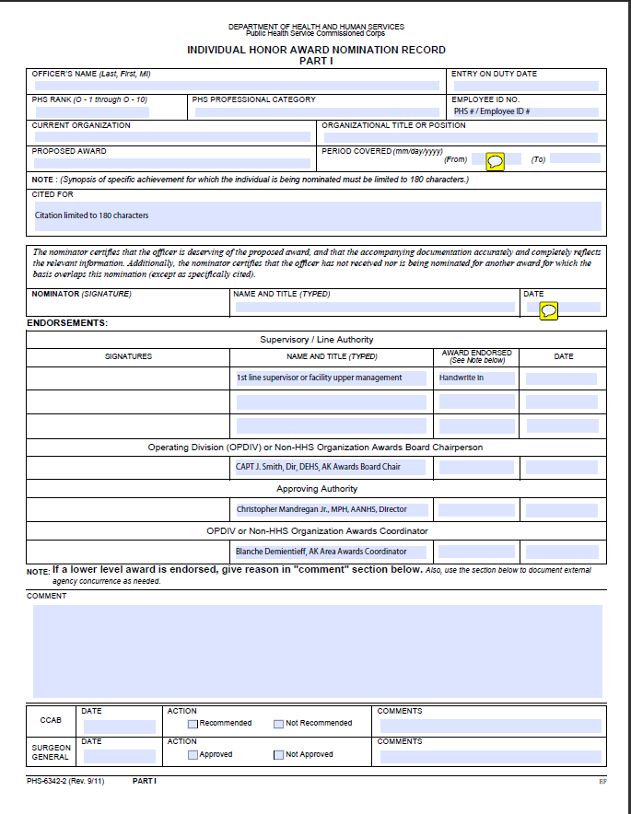

Cover Sheet for AM or CIT

Narrative Example
JUSTIFICATION FOR AWARDING
THE UNITED STATES PUBLIC HEALTH SERVICE

[CITATION, ACHIEVEMENT/COMMENDATION MEDAL] TO
[SPELL OUT RANK AND NAME]

Cited For
A short paragraph to say what it is the officer is being nominated for be specific and include the officer’s organization, beginning date (as “Month Year”) and ending date (as “Month Year). This should match exactly what is written on the Cover Sheet in the “Cited For” box and in the “Conclusion” section of this narrative (25-word limit for the citation box).

Example
[LT Soapy Smith] is nominated for the United States Public Health Service (USPHS) [Achievement Medal] for [providing outstanding operations, budget, and staff management and saving project staff time and funds] from [October 2008] to [June 2009.]

Background
A paragraph describing the conditions that existed prior to the individual or group accomplishment. It must include information about the nominee, his/her regular duties, and a description of the problem. This section is where you set the stage for the award nomination. You might start generally and narrow down to specifics. You might mention what the organization does, how this nomination fits into the organization’s work, why this accomplishment is important, was there a problem that needed to be solved or a process that needed improvement? Why was it important to fix the problem, make the improvement, or implement the change?

Example
Physical inactivity (PI) is a major public health problem, increasing the risk for obesity, coronary heart disease, some cancers, diabetes, high blood pressure, and depression. The triad of PI, poor nutrition, and obesity accounts for over 300,000 yearly U.S. deaths. PI adds an estimated $75 billion to medical costs. Sedentary lifestyle has emerged as one of our greatest and most pressing public health challenges. Yet, limited resources have been devoted to combating it. In early 2008, the Robert Wood Johnson Foundation (RWJF) gave $746,650 for economic analyses of community interventions to decrease PI. Because of hiring delays, the study did not begin until April 2008. The investigators were trying to not only do the science, but also manage the mechanics of the project, resulting in operational delays, e.g., irregular communications with partners and non-payment of consultants. In October 2008, LT Soapy Smith was recruited to improve the operational side of Project MOVE (Measurement of the Value of Exercise).

Accomplishments
A paragraph describing the achievement or success that was done by the individual meriting the award. There should be one notable accomplishment for a Citation, two notable or one significant accomplishment for an Achievement. A Commendation and above will be for significantly more worthy achievements. Review the criteria for each type of award (see PHS CO Awards CCPM Pamphlet No. 67). You should tell specifically what the person or group did, who was involved, how they did what was done, what obstacles were overcome. Say if performance measures used. What outcomes were anticipated? You may want to bulletin the accomplishments. Were they a leader? It must include specific information on what the officer or group did to correct the situation addressed in the Background section, and how the officer’s achievement was above and beyond the expected performance of duty.

Minimum Requirements
- 1 Accomplishment for a USPHS Citation
- 2 Accomplishments for a Achievement Medal
- A Commendation and above will be for significantly more worthy achievements. Review the criteria for each type of award on page 1.

Example
- From October 2008 to June 2009, LT Smith set up monthly calls to RWJF, frequent calls with the CDC Foundation (CDCF), and bi-weekly internal team meetings. He established the agendas, set up the phone bridges, and provided summaries with action items. He facilitated the technical and scientific work of the 36-member project team through efficient project organization, i.e., creating notebooks that documented agendas, summaries, and action items and operations (travel, contracts, and budget). Prior to his involvement, no one set agendas, produced meeting notes, or documented decisions. His summary notes and action items document the team’s decisions and reasons behind decisions so that the team can move forward quickly and efficiently.
- LT Smith set up three workshops (October 2008 in New York, February 2009 in San Diego, June 2009 in Seattle) to gain input from research partners on the cost model, methodology, and data gaps. He managed communications such that issues raised by partners were voiced to the team so that solutions could be found. He produced follow up meeting notes from each Workshop, summarized discussions, and produced action item lists. He saw to it that researchers’ travel was properly arranged, they were reimbursed for travel expenses, and they were paid for appropriate consulting time by the CDC Foundation. LT Smith coordinated follow up calls from the Workshops, established the agendas, set up the phone bridges, and produced call summaries to document decisions and itemizes remaining data gaps.

Impact/Outcome
A paragraph describing the strong effect or result the officers’ accomplishment on the mission of the PHS at the international, national, regional, OPDIV, agency or local. The more you can quantify the better. Being published is not an impact; but having an officer’s publication use to change policy is an impact. What were the results of the efforts described in the Accomplishment section? Improved effectiveness, better communication, faster/slower, bigger/smaller, more return/less cost, more satisfaction/less complaints, improved health, on time, on budget, meeting scope. It is always of more impact if objective evidence or statistics can be used. Did this further the organizations goals or mission, can this be measured? If possible, support the description with statistics, examples or any tangible data.

Minimum Requirements
- 1 Impact/Outcome for a USPHS Citation
- 2 Impact/Outcome for a Achievement Medal
- A Commendation and above will be for significantly more worthy achievements. Review the criteria for each type of award on page 1.

Example
- His work allowed the scientists on the team to focus on the cost model. The improved operations and communications kept everyone updated on evolving issues to move the project forward (prior to his work, no systematic communications occurred). There is now improved oversight on the project, i.e., monthly calls to RWJF, weekly meeting notes, and action items to drive the project to completion. These are vital to solve issues and bridge data gaps essential for the project’s success.
- These tasks were important to help the team identify and bridge remaining data gaps and get buy in on the model. Consultants’ invoices were paid within 2 weeks of the Workshop; prior to her efforts, consultants had not been paid and no one was following up. Back payment of 13 invoices ensured consultants’ continued cooperation, input, and work on the project, and illustrated to them that the project was running smoothly and efficiently. Setting up the workshops and follow-up calls and producing summaries were vital to solve issues and close data gaps, keep everyone updated, and move the project forward.
- From February 2009 to June 2009, LCDR Smith creatively promoted a cheaper method of travel by using the CDC Foundation rather than SATO (he ascertained that airfares from the CDCF’s travel agency were significantly less than SATO). He established operating procedures to use the Foundation systems and trained staff on completing invoices for reimbursement. The new process has saved over $2,500 in project funds for trips to Brazil and Seattle. These savings have freed up money up for other components of the Project and make the most of the RWJF grant money.
- From November 2008 to February 2009, LCDR Smith assisted in negotiating the deliverables and price for three subcontracts for project data (UCLA, UCSD, and Milliman). He verified the work was completed and made sure they were paid (~$236,000). LCDR Smith saved money through his negotiating skill. He convinced UCLA to decrease their price by ~$20,000 and UCSD by $4,300. He managed to halve the Milliman contract, thus saving $115,000. These “saved” funds were used to fund additional consultants to complete the model by filling in unanticipated crucial data gaps, thus improving the model by incorporating quality of life issues and conducting health impact assessments for walk-to-school and the Buford Highway project, both aimed at increasing physical activity.

Conclusion
A brief summary emphasizing importance of the work. This section needs only to be a few sentences that end the narrative. This should include the officer’s organization, beginning date (as Month Year) and ending date (as Month Year). This should match exactly what is written on the Cover Sheet in the “Cited For” box and the “Cited For” section of this narrative.

Example
LT Smith saved $143,800 that could be used elsewhere on the project, thus strengthening it. Furthermore, his assumption of the operational side of the project allowed the scientists to focus on science. The standard operating procedures he created have improved communications, and these procedures have been vital in solving issues, bridging data gaps, and moving things forward. His “nuts and bolts” management of Project MOVE has been instrumental to its success so far. Therefore, LT Soapy Smith is proudly nominated for the USPHS Achievement Medal for providing outstanding operations, budget, and staff management and saving project staff time and funds from October 2008 to June 2009.

Alternative Narrative Layout

Same as below but with the impact/outcome following each accomplishment, ideally in bullet format. This is suitable when there is a direct one-to-one relationship between accomplishment and impact/outcomes.

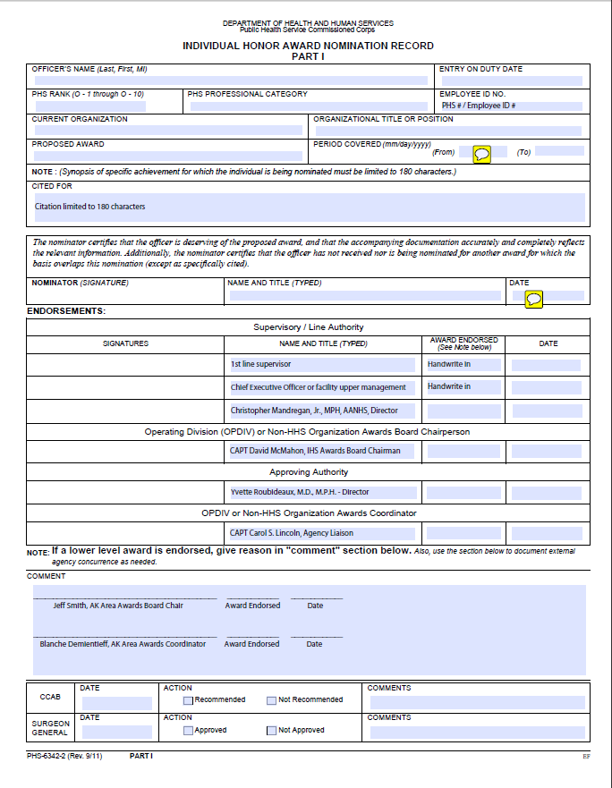
Cover Sheet for CM & Above

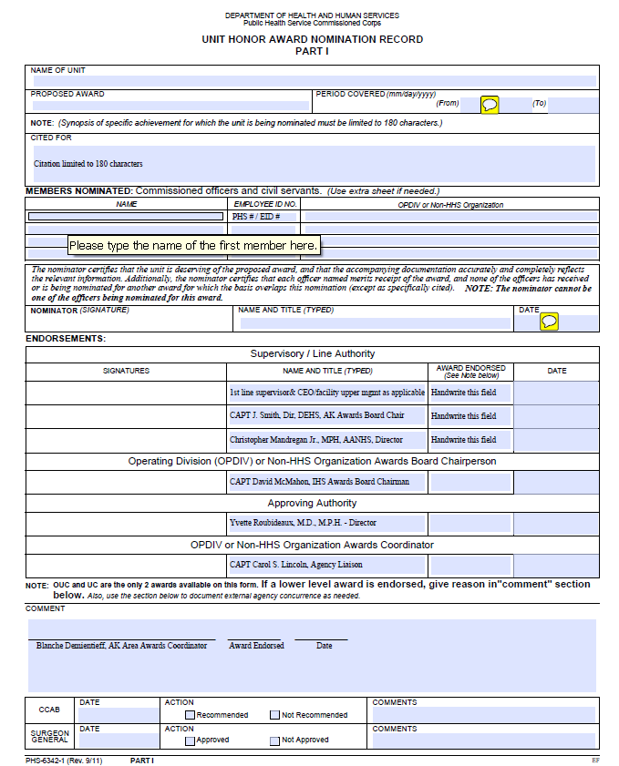

Cover Sheet for UC or OUC

